Parent's Handbook for Public Schools
- What is uEducateUs?
  - uEducateUs at Our School
  - Parent Logins
- Getting Started
  - COMPUTER (both Mac and Windows based PC)
  - Mobile devices (phones or tablets) either Apple or Android
- The Basics
- Further Help
- Attendance
  - Absent Notes
  - Unexplained Absences
- Communication
  - Conversations
  - Newsletters
- Student Information
- Medical Information
  - Changes to Medical Information
  - New Medical Condition
- Events
  - Diary
  - Interviews
  - Events
  - Permission Slips

What is uEducateUs?
uEducateUs is an internet based School Management System that can be used on any computer with an internet browser, as well as IOS and Android phones and tablets.
The uEducateUs system not only stores student data but also handles attendance, absences, homework tasks, communication between teachers and parents and much more.

uEducateUs at Our School
A comment by one of the schools using the uEducateUs system…
We see great potential in the uEducateUs system to assist us as a whole school community to manage data, streamline our processes and facilitate communication between parents and teachers. Although this system is still new for our school, we believe that it will continue to be a positive growth experience and help us to keep pace with technology.
We are endeavouring to get all of our school families on board and we ask that all of our teachers, parents and office staff, be patient and understanding as we adjust to changes, identify issues and make adjustments as necessary.

Parent Logins
- All parents have individual accounts to access uEducateUs.
- Parents only have access to information relating to their own children.
- Parent logins can be obtained from the School Office.
- It will take time to become familiar with the system and we recommend that parents try and make use of it as much as possible so that they become more familiar with its various features and become comfortable using it.
- Your school has decided to use uEducateUs as it will make administration easier while saving them a lot of time performing various administrative functions. Your school admin staff are keen to get parents on board so are happy to answer questions, offer assistance or to sit down with you and go through it with you if you require. Please contact your school admin staff if you require assistance using the uEducateUs system from a parent’s perspective.
- If you find issues with the system or have suggestions or feedback, please feel free to raise a support ticket, there is a link to do so at the end of this how-to article.

Getting Started
uEducateUs can be accessed using any internet enabled computer or mobile device. You are not limited to one device, i.e. you can use it on both your phone and your computer depending on where you are and what device you have access to at the time.
Follow these instructions to access the system:
You will require your login details to continue. If you do not know what your username and password is, please contact our school before continuing.

COMPUTER (both Mac and Windows based PC)
- Open your web browser
Any up to date web browser is suitable.
If your browser is not up-to-date, certain functions within the system may not work as designed.
You should update your browser regularly, if you don’t have automatic updates enabled on your computer.
- Go to the url on the Parent Welcome Letter that was set out by your school.
If you don’t have the letter, but do know your username and password, go to this URL:
https://login.ueducateus.com.au/
- Enter your Username and Password:
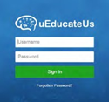

Mobile devices (phones or tablets) either Apple or Android
- Open the App Store (Apple) or Play Store (Android):
- Search for uEducateUs
- Download the application
- Enter your Username and Password
- After your initial sign in with your username and password you have the option to set up a 4-digit pin to make accessing the app quicker in the future.

The Basics
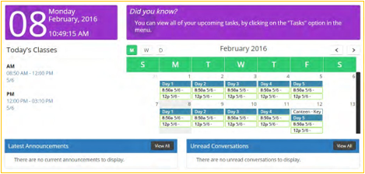
When you log in to your account you will go to the home page.
This page contains a summary of important information and reminders.
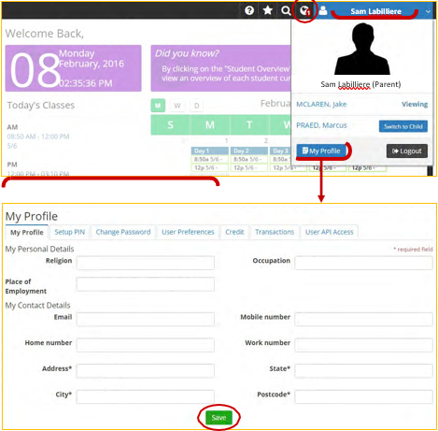
At the top of the home page will be a black bar with icons. You will see your name at the far right, which drops down to reveal more options.
The globe icon indicates whether you have any notifications, such as a reply to a communication.
My Profile
You can use the My Profile section to view your personal information and contact details. If any of your information is incorrect, please contact the school to have it updated.
You can also change your password, setup a PIN for mobile devices and change your preferences for receiving notifications.

Further Help
Please remember that it takes time to adjust to a new way of doing things, both as individuals and as a school community, and it will take time to become familiar with how things work.
If you have questions, queries or difficulties with any aspect of uEducateUs please don’t hesitate to contact your School administration staff.
As this system is also still relatively new, technical difficulties do sometimes occur. Please report any errors to the School office so that they can pass them on to the uEducateUs support team.

Attendance
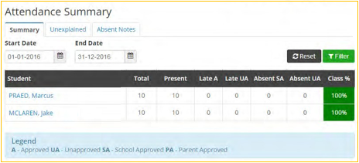
All class attendance rolls are marked electronically using the uEducateUs system. Rolls are marked twice a day, for AM and PM sessions.
We appreciate parents’ help and cooperation in keeping our attendance records accurate and up-to-date…
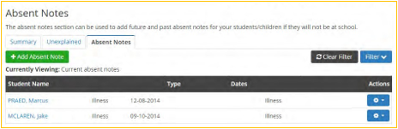

Absent Notes
Parents have the option to submit electronic absent notes via the uEducateUs system as opposed to sending a note with their child when they return to school.
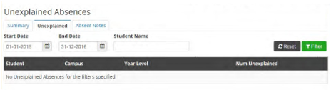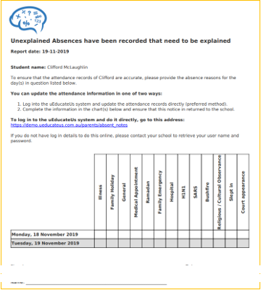

Unexplained Absences
If a student is not present and no explanation has been received at the time of marking the rolls, the student will be marked as Unexplained until an explanation from the parent is provided.
Reminder letters (like the one to the left) with a list of student unexplained absences will be sent out by the school regularly, so that Unexplained Absences can be kept to a minimum.

Communication
Please note that any urgent or timely information needs to be communicated to the school via phone. uEducateUs messages should be treated the same as emails - they will be checked regularly but are not instant like a phone call.
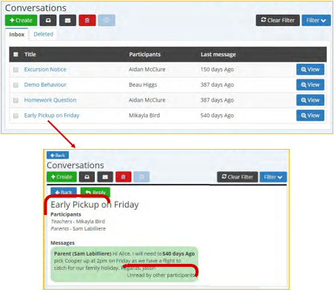

Conversations
Parents are able to communicate with their child’s teachers as well as the admin staff using Conversations. Teachers and admin staff can also send messages to parents with reminders and requests. Unread conversations will appear on the Homepage.
Each conversation will identify the participants involved.
People in the conversation can see whether their message has been read by the other participants.
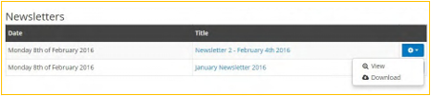

Newsletters
Parents can now access school newsletters at any time and wherever they are.

Student Information
Overviews → My Children
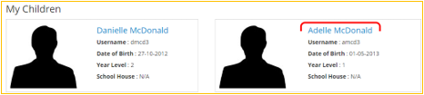
All of the information provided on the Application for Enrolment form at the student’s time of enrolment is entered into the database for access by admin staff and teachers.
Additional information is added as needed (i.e. Behaviour logs, new Medical information, etc.) Parents are also able to view their child’s information when necessary.
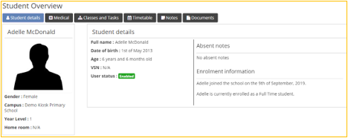
To view a summary of your child’s classes, attendance etc.:
- click on their name
- then click on the Classes and Tasks tab to select their class.
If you notice that any student information is incorrect, please advise your school so it can be updated.

Medical Information
Overviews → My Children
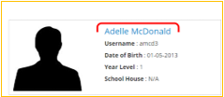
Student medical details are entered on the system so that they are accessible by teaching and admin staff at all times. Please help your school keep their data up-to-date by informing them off any changes or additions to the information relating to your children as soon as possible.
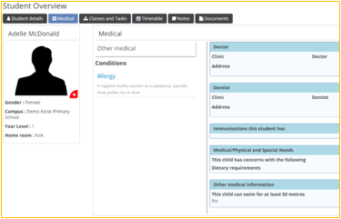

Changes to Medical Information
Parents are able to view their child’s current medical information but are not able to edit it.
Any changes to existing medical information need to be communicated to the school as soon as possible.
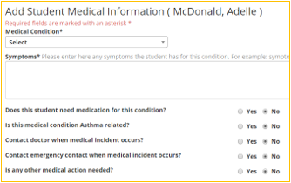

New Medical Condition
Parents are able to add a new medical conditions when approving a permission slip if it has not been previously recorded. Please provide as much detail as you can to help staff members care for your child. Supporting documentation can also be uploaded.
New medical conditions will be classified as Pending until approved by a school administrator.

Events
The events found in the Events section may change depending on which child you are viewing.
To switch between your children, click on your name in the top right hand corner and select the child you would like to view.
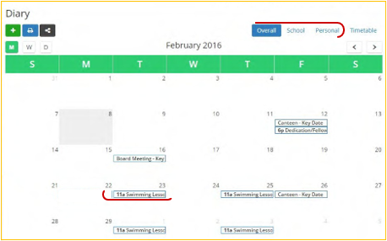

Diary
School events and key dates are entered into the school calendar by School Admin staff and teachers. Only events that apply to your child, will be displayed in their calendar.
You can view the calendar in three ways:
- with all of your events
- just school events
- just your personal events
For more details about an event click on the event in the calendar.
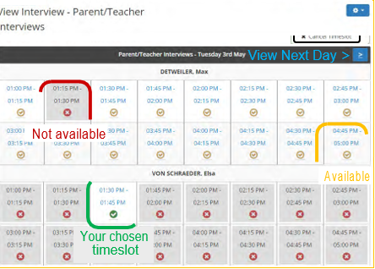

Interviews
Parent/Teacher Interviews
- Select an available timeslot.
- Choose your child’s name from the list box.
- Repeat - to pick timeslots for all your children.
If you need to change your interview time:
- Click Cancel Timeslot and select the timeslot you would like to cancel.
- Select a new timeslot.
Please check your dates and times carefully
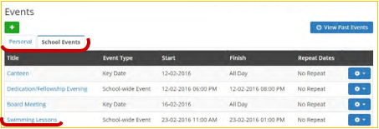

Events
A list of school events and key dates can be found on the events page.
Similar to the Diary, you can choose to view school or personal events.
For more details about an event simply click on the event’s title.
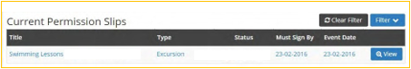

Permission Slips
- Click on the permission form to view it.
- Following all of the details of the excursion, at the bottom of the page you will be asked to Accept or Decline your permission.
Permission slips will also appear on the Homepage.

